Massachusetts Science and Engineering Fair 2025

Analyzing different machine learning algorithms in predicting the likelihood of cardiovascular diseases and exploring health attributes as important predictors

Soumalya Chatterjee

Table of Contents:

Introduction ------------------------------------------------------------------------- 2
Dataset -------------------------------------------------------------------------------- 3
Experimentation and Methodology ----------------------------------------------- 4
Logistic Regression ----------------------------------------------------------------- 5
Support Vector Machine ----------------------------------------------------------- 6
K-Nearest Neighbors --------------------------------------------------------------- 7
Neural Network --------------------------------------------------------------------- 8
Random Forest ---------------------------------------------------------------------- 9
Feature Impacts --------------------------------------------------------------------- 11
Conclusion -------------------------------------------------------------------------- 12
Bibliography ------------------------------------------------------------------------ 13

Introduction
Abstract: Cardiovascular diseases (CVDs), including stroke, myocardial infarction, and other related conditions, are the leading causes of death globally, accounting for approximately 17.9 million deaths worldwide in 2019, with 702,880 deaths in the United States alone in 2022. The early prediction of CVDs is critical for effective intervention and prevention strategies. Machine learning (ML) algorithms have gained significant attention in the healthcare domain, particularly for predicting the likelihood of future cardiovascular events. This study aims to perform a comparative analysis of several machine learning models in predicting the occurrence of CVDs, focusing on precision, accuracy, F1 score, and recall as evaluation metrics. The research also explores the influence of different feature combinations from 14 attributes of medical records on the prediction capability. A publicly available dataset of 302 patients was collected and processed for this study, including steps of data formatting, cleansing, transformation, and labeling. The various ML models used in this study include Logistic Regression (LR), Support Vector Machine (SVM), K-Nearest Neighbors (KNN), Multi-Layer Perceptron (MLP), and Random Forest (RF). An 80-20 split was used between train and test data for each supervised model. Performance for each was evaluated on the statistical parameters. The experimental analysis demonstrated that the Multi-Layer Perceptron classifier is the most appropriate against LR, SVM, KNN, and RF with 85.9% accuracy, recall, precision, and 85.7% F1 score. In addition, this study uses Principal Component Analysis (PCA) as a method of visualizing the data and seeing which algorithms perform the best with dimensional reductions. Finally, using feature selection, we found that the slope of peak exercise, number of major vessels, and thalassemia test results were the biggest individual contributors with 14%, 17%, and 17% respectively.
Rationale: According to the World Health Organization, Cardiovascular diseases (CVDs) such as stroke and myocardial infarction, are the leading causes of death worldwide, accounting for an estimated 17.9 million deaths globally in 2019. They are also the leading cause of death in the United States, with an estimated 702,880 deaths in 2022. Machine learning algorithms have brought new insight by being able to extract and identify much more data and features than the average doctor, allowing for more accurate diagnoses, personalized care, and be used to calculate the probability of a future occurrence of CVD. One study comes from Elias Dritsas, Sotiris Alexiou and Konstantinos Moustakas paper titled Cardiovascular Disease Risk Prediction with Supervised Machine Learning Techniques where they used a publicly available dataset to find that Logistic Regression had the highest performance of the models based on accuracy, recall, and area under the receiver-operator (ROC-AUC) curve score. Another study titled Prediction of incident cardiovascular events using machine learning and CMR radiomics by Esmeralda Ruiz Pujadas and others, used methods like radiomics (an algorithm for analyzing medical images to extract quantitative features that can help predict the behavior of cancer and how it will respond to treatment) and see its effectiveness in predicting CVDs. This study performs a comparative of various machine learning algorithms in predicting the likelihood of different cardiovascular diseases analysis in terms of precision, accuracy, f1 score, and recall. In addition, it explores which attribute (features) combinations will have the greater influence on prediction capability, allowing immediate and precise precautions to be taken to prevent the likelihood of a person to develop a CVD in the future.
Engineering Claim: Machine learning algorithms can predict the likelihood of a future cardiovascular disease such as stroke or myocardial infarction from a patient's medical records.
Dataset
In this study, the Respiratory Disease dataset, a tabular dataset from UCI’s Machine Learning Repository, was used. In particular, the Cleveland database is the only one that has been used by ML researchers to date. This dataset is comprised of 302 individuals, each with 76 attributes. However, the model training only used 14 of these attributes since all prior published experiments refer to this subset in addition to the statistical significance and removal of missing data in the remaining columns. The dataset was then processed and analyzed using Python in Google Colab, where various machine learning models found in scikit-learn were implemented.
List of the 14 attributes:
- age: Age in years
- sex: Sex(1= male, 0= female)
- cp: Chest pain type (Value 1: typical angina, Value 2: atypical angina, Value3: non-anginal pain, Value 4: asymptomatic)
- trestbps: Resting blood pressure (in mmHg on admission to the hospital)
- chol: Serum Cholesterol in mg/dl
- fbs: fast blood sugar > 120 mg/dl (1= true, 0=false)
- restecg: Resting electrocardiographic results (0: normal, 1: having ST-T wave abnormality (T wave inversions and/or St elevation or depression of > 0.05mV, 2: showing probable or definite left ventricular hypertrophy by Estes Criteria)
- thalach: Maximum heart rate achieved
- exang: Exercise included angina (1= yes, 0=no)
- oldpeak: ST depression induced by exercise relative to rest
- slope: the slope of the peak exercise ST segment (Value 1: upsloping, Value 2: flat, Value 3: downsloping)
- ca: Number of major vessels (0-3) colored by fluoroscopy
- thal: 3= normal, 6= fixed defect, 7= reversible defect
- HeartDisease: Diagnosis of heart disease- angiopathic disease status
  - Value 0: <50% diameter narrowing,
  - Value 1: > 50% diameter narrowing
Age (years) and sex (1=male, 0=female) are key demographic factors influencing heart disease risk. Chest pain type (cp) categorizes patients into four groups: typical angina, atypical angina, non-anginal pain, and asymptomatic. Resting blood pressure (trestbps) and serum cholesterol (chol) levels provide critical insights into cardiovascular health. Fasting blood sugar (fbs) indicates whether blood sugar levels exceed 120 mg/dl (1=true, 0=false), an important factor in assessing diabetes-related heart risks. Resting electrocardiographic results (restecg) are classified into normal (0), ST-T wave abnormalities (1), and probable left ventricular hypertrophy (2). Maximum heart rate achieved (thalach) and exercise-induced angina (exang, 1=yes, 0=no) assess cardiac response to exertion. ST depression induced by exercise (oldpeak) and slope of the peak exercise ST segment (slope: 1=upsloping, 2=flat, 3=downsloping) measure heart function under stress. Number of major vessels (ca) colored by fluoroscopy (0-3) and thalassemia test results (thal: 3=normal, 6=fixed defect, 7=reversible defect) provide additional diagnostic indicators. The target variable, HeartDisease, classifies patients based on angiopathic disease status, with 0 indicating <50% artery narrowing and 1 indicating >50% narrowing, a threshold for significant CVD risk.
Snippet of medical record in tabular format: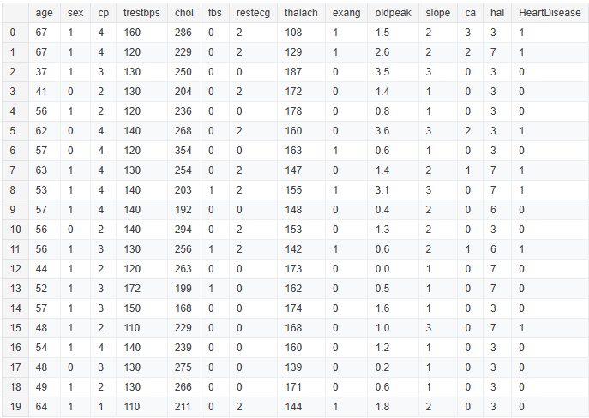
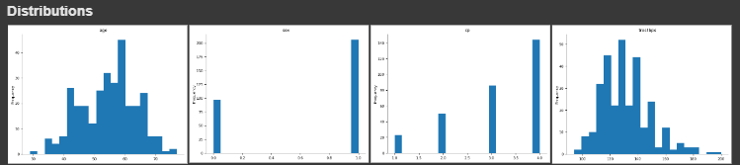
The above charts explore the frequencies of certain attributes such as age, sex, chest pain variants, and resting blood pressure.

Experimentation and Methodology

Procedure steps in this study
- Collect publicly available multiple dataset on patient outcome on cardiovascular disease
- Import dataset to editor to analyze attributes and select the data set to use (the one i used)
- Data preparation - formatting, transformation, cleansing, labeling
- Develop code in python using scikit-learn and panda to build ML models (Support Vector Machine, Neural Network, Logistic Regression, Random Forest, and K-Nearest Neighbors)
- Use 80 % of dataset to train each ML model
- Use 20% of dataset to test each model based on parameters - precision, accuracy, f1 score, and recall
- Repeat step 5 and 6 for each model and record output
- Perform comparative analysis from result visualization

Data Preparation: Numerical features were normalized using Min-Max scaling to ensure consistency across attributes. For model evaluation, the data was split into training and test sets, with 80% for training and 20% for test data. To mitigate class imbalances, a method called Synthetic Minority Over-sampling Technique (SMOTE) was used. SMOTE is a statistical technique for increasing data for minority classes to create balance in the data distribution. This in turn, improves scores and overall performance metrics. The target variable (y_pred), which represents the presence of CVD or not, was converted to binary values. Once the data was cleansed, it was evaluated using K-Nearest Neighbors (KNN), Support Vector Machine (SVM), Neural Networks (MLP), Logistic Regression (LR), and Random Forest (RF). Each model’s performance was assessed by accuracy, precision, recall, and F1-score. The final output also includes a classification report about the micro average and weighted average and a confusion matrix.

How each metric is measured:
- Accuracy - A measure of how close a targeted value is to the true value
- Micro-Weighted Precision - The degree to which represents the closeness between multiple measurements to each other, regardless of accuracy.
- Micro-Weighted Recall - A measure of how consistently a machine learning model retrieves similar results as past attempts.
- Weighted F1 Score - A class-weighted harmonic mean of precision and recall.

Logistic Regression
A classification algorithm that predicts a categorical output variable using categorical or numerical input variables, also known as the sigmoid function (S-Curve).
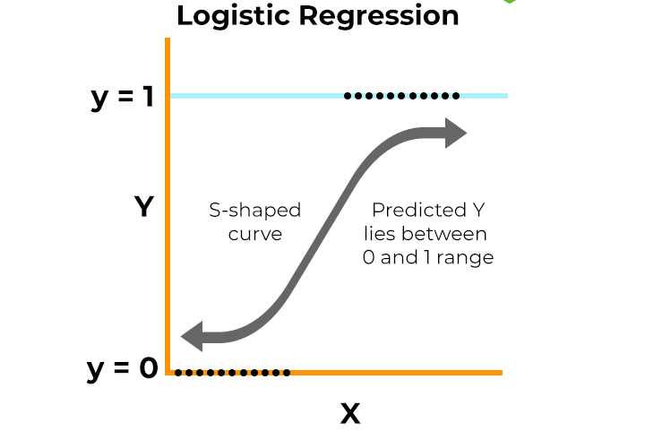
Parameters: Regularization is controlled through penalty (L1, L2, or Elastic Net) and C, which balances simplicity and accuracy. Solvers like lbfgs and liblinear optimize model training, while class_weight can be adjusted for imbalanced datasets.
Results obtained from using the LR classifier are shown below.
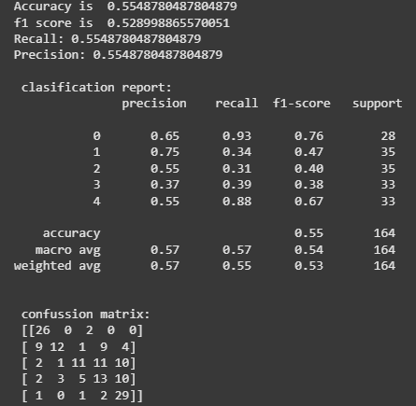

Support Vector Machine

A classification algorithm that draws a decision boundary (line) between data points of a training set that separates the classes with the largest margin possible. It is reliable because knowing the support vectors is enough to classify new possible data points.
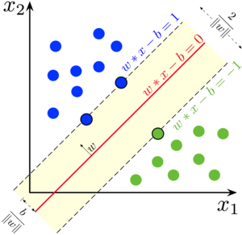
Parameters: SVM supports different kernels (linear, RBF, polynomial) to handle linear and non-linear data, with C controlling the trade-off between margin maximization and classification accuracy. Gamma determines the influence of data points in non-linear kernels, while class_weight helps handle imbalanced datasets.
Results obtained from using the SVM classifier are shown below.
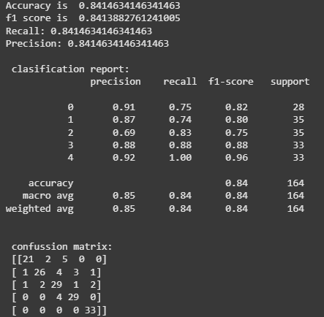
K-Nearest Neighbors

A non-parametric algorithm that can be used for both regression and classification. For any given new data point, the algorithm will predict the target to be the average of its K-nearest neighbors.
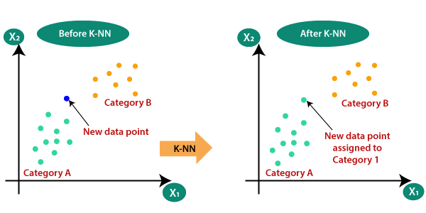
Parameters: The key parameter n_neighbors (K) determines how many neighbors influence a prediction, where lower values make the model more sensitive to noise, while higher values improve generalization. Additional parameters include metric (e.g., Euclidean, Manhattan) for distance calculation and weights (uniform or distance-based), which affect how neighbors contribute to the prediction.
Results obtained from using the KNN classifier are shown below.
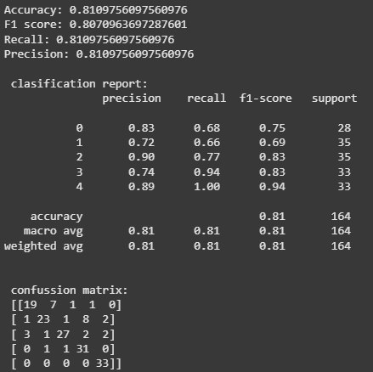
Neural Network
A neural network, specifically a Multi-Layer Perceptron (MLP), is a type of artificial neural network consisting of multiple layers of neurons: an input layer, one or more hidden layers, and an output layer. Each neuron in a layer is connected to neurons in the subsequent layer, and the network learns by adjusting weights through backpropagation to minimize errors in its predictions. The algorithm is commonly used for tasks like classification and regression, where it can model complex, non-linear relationships in the data.
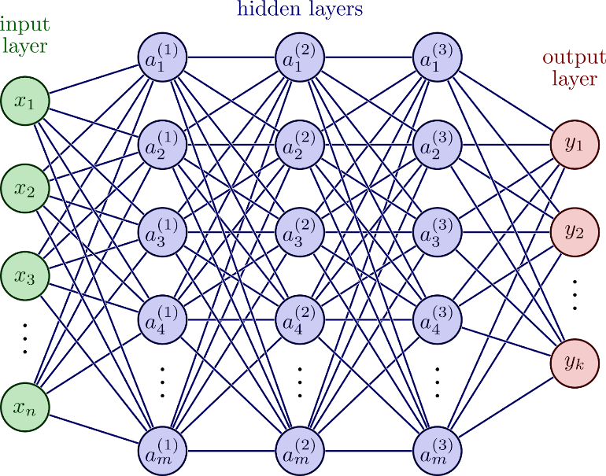
Parameters: Key parameters include hidden_layer_sizes, which defines the number of neurons in each hidden layer, and activation functions (ReLU, sigmoid, tanh) that determine how signals are processed. Optimization is controlled by solvers (Adam, SGD, lbfgs), with alpha acting as a regularization term to prevent overfitting.
Results obtained from using the MLP classifier are shown below.
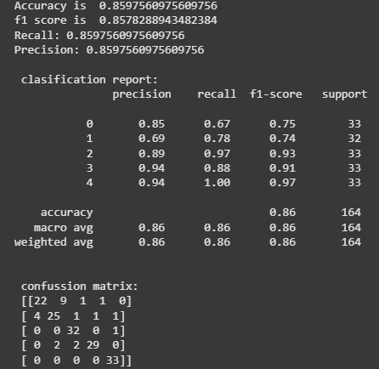

Random Forest

An algorithm that creates a collection of decision trees, typically trained with different subsets of data, and combines their predictions to improve accuracy and reduce overfitting. Each tree in the forest makes an independent prediction, and the final output is determined by aggregating the results, such as through majority voting for classification tasks or averaging for regression tasks.
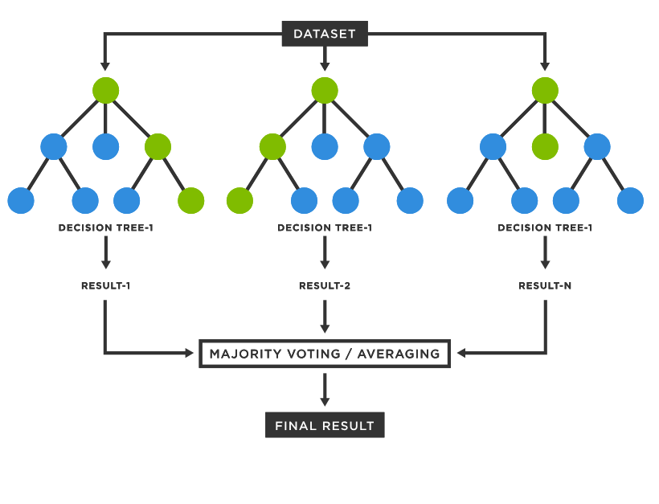
Parameters: Key parameters include n_estimators, which defines the number of trees, max_depth to control tree complexity, and criterion (Gini or entropy) for measuring split quality. Additional parameters like min_samples_split and min_samples_leaf prevent overfitting by ensuring sufficient data points in each split.
Results obtained from using the RF classifier are shown below.
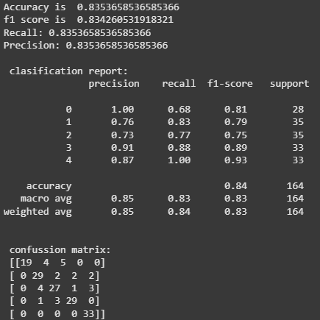
Feature Impact
Principal component analysis (PCA) is a way to mathematically reduce dimensions to simplify a large data set into a smaller one, all while maintaining its core patterns and trends. From the dataset relative importance of individual features are calculated.
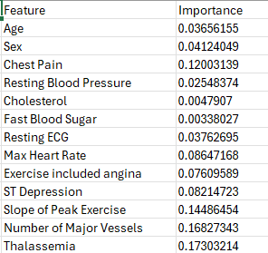 | 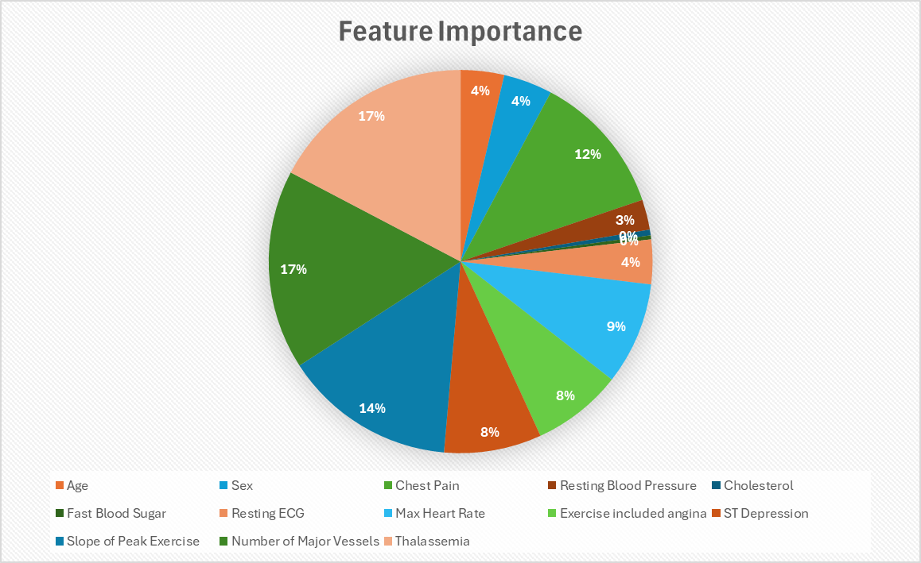

Experimental Results Comparison

The following chart summarizes the performance of all five machine learning algorithms, measured along four key parameters namely accuracy, precision, recall and F1 score.
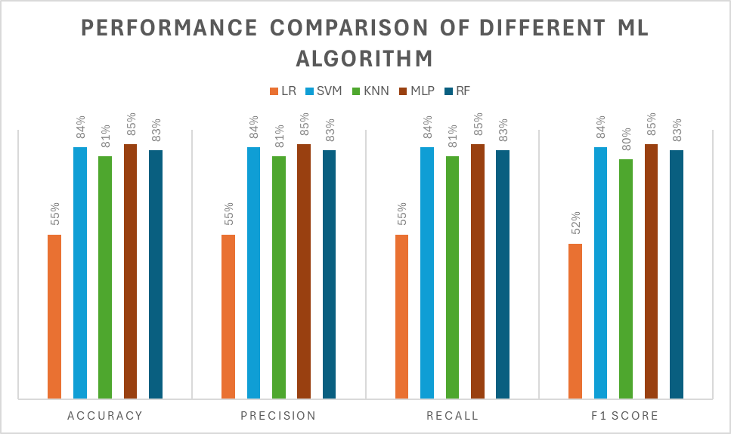

Conclusion

In this study we explored the efficacies of different machine learning algorithms in their abilities to predict the likelihood of a future heart . The experiment demonstrated that the Multi-Layer Perceptron classifier is the most appropriate against LR, SVM, KNN, and RF with 85.9% accuracy, recall, precision, and 85.7% F1 score. The classifier with the lowest scores observed was Logistic Regression with 55.4% accuracy, recall, precision, and 52.9% F1 score. Logistic regression usually performs better in case of binary classification. The relatively poor performance, hence, can be explained as we have used a multiclass dataset.
In the future, some potential next steps would be to extract new features from other sensor data and medical imaging, to check improvement in the algorithm. A more exploratory analysis may reveal potential anomalies and find more correlations using feature selection and PCA.

Bibliography

Ahmadpk. (n.d.). Heart disease classification. Kaggle. Retrieved January 15, 2025, from https://www.kaggle.com/code/ahmadpk/heart-disease-classification
National Library of Medicine. (2022). Prediction of incident cardiovascular events using machine learning and CMR radiomics. PubMed. Retrieved January 15, 2025, from https://pubmed.ncbi.nlm.nih.gov/36512045/
ResearchGate. (2022). Prediction of incident cardiovascular events using machine learning and CMR radiomics. ResearchGate. Retrieved January 15, 2025, from https://www.researchgate.net/publication/366262921_Prediction_of_incident_cardiovascular_events_using_machine_learning_and_CMR_radiomics
Goldberger, A. L., et al. (2000). Sudden cardiac death: Music and sudden cardiac death dataset. PhysioNet. Retrieved January 15, 2025, from https://physionet.org/content/music-sudden-cardiac-death/1.0.0/
ScitePress. (2022). Cardiovascular Disease Risk Prediction with Supervised Machine Learning Techniques. Retrieved January 15, 2025, from https://www.scitepress.org/Papers/2022/110883/110883.pdf
Machine Learning Mastery. (n.d.). SMOTE oversampling for imbalanced classification. Retrieved January 15, 2025, from https://machinelearningmastery.com/smote-oversampling-for-imbalanced-classification/
ArXiv. (n.d.). Tabular data augmentation for machine learning: Progress and prospects of embracing generative AI. Retrieved January 15, 2025, from https://arxiv.org/pdf/2407.21523
GeeksforGeeks. (n.d.). Principal component analysis with Python. Retrieved January 15, 2025, from https://www.geeksforgeeks.org/principal-component-analysis-with-python/
Built In. (n.d.). Step-by-step explanation of principal component analysis (PCA). Retrieved January 15, 2025, from https://builtin.com/data-science/step-step-explanation-principal-component-analysis#:~:text=Principal%20component%20analysis%20(PCA)%20is%20a%20dimensionality%20reduction%20and%20machine,maintaining%20significant%20patterns%20and%20trends
ArXiv. (n.d.). MobileNets: Efficient convolutional neural networks for mobile vision applications. Retrieved January 15, 2025, from https://arxiv.org/pdf/1704.04861

